
DUY TAN UNIVERSITY
INTERNATIONAL SCHOOL

Software Testing
CMU-SE 303 KIS
HOMEWORK
Version 1.0
Date: Nov 13th, 2026

Using Robot FrameWork to Perform Automated Functional Testing on the Login Testing Application
Created by <MIS>

Full Name: Linh, Nguyen Thi Thuy
Student ID: 30205149111

Approved by
Sanh, Tran Kim

Software Testing - Mentor:
Name Signature Date

PROJECT INFORMATION
Project acronym | TLTA
Project Title | The Login Testing Application
Start Date | 1 Nov 2026 | End Date | 13 Nov 2026
Lead Institution | International School, Duy Tan University
Project Mentor | Sanh, Tran Kim
Scrum master/ Project Leader & contact details | Linh, Nguyen Thi Thuy  Email: Linh, Nguyen Thi Thuy @dtu.edu.vn  Tel: 0379937256  ID: 30205149111
Partner Organization | Duy Tan University
Demo Link | https://github.com/nguyentthuylinh90-dev/Robot-FrameWork.git

REVISION HISTORY
Version | Date | Description
Draft | 1 Nov, 2026 | Initial project report and testing plan.
v1.0 | 13 Nov, 2026 | Completed testing and result analysis.
TABLE OF CONTENTS
1. Introduction to the Login Testing Application 5
2. Introduction to Robot Framework 5
3. Test Case Details 6
3.1. BlackBox Testcase 7
3.2. Equivalence Table 7
3.3. Equivalence Partitioning Test Case Mapping 8
3.4. Boundary Table 9
3.5. Decision Table 9
3.6. WhiteBox TestCases 10
3.7. Source Code 10
3.8. Control Flow Graph ( CFG ) 11
3.9. Statement Coverage 13
3.10. Branch Coverage 13
4. Summary Table 14
5. Evidence 15
5.1. Test Scripts & Execution Logs 16
5.2. Summary of Defects and Issues Found During Execution 22
6. Conclusion 23

LIST OF TABLES
Table 1: Black-Box Test Cases Table 7
Table 2: Equivalence Partitioning Table 8
Table 3: Equivalence Partitioning Test Case Mapping 8
Table 4: Boundary Value Analysis Table 9
Table 5: Decision Table 9
Table 6: White-Box Test Cases Table 10
Table 7: Statement Coverage Table 13
Table 8: Branch Coverage Table 13
Table 9: Comprehensive Summary Test Results Table for 30 Test Cases 14

LIST OF FIGURES
Figure 1: Sample Login Page Interface 5
Figure 2: Robot Framework Logo 6
Figure 3: JavaScript Login Function Source Code 11
Figure 4: Control Flow Graph - CFG 12
Figure 5: Robot Framework Test Script 16
Figure 6: Terminal CLI Execution Output ( TC01-TC12) 17
Figure 7: Terminal CLI Execution Output ( TC13-TC22 ) 17
Figure 8: Terminal CLI Execution Output ( TC23-TC30 ) 18
Figure 9: Test Statistics Summary Report 18
Figure 10: Execution Log of Failed Test Case TC20 19
Figure 11: Execution Log of Failed Test Case TC22 19
Figure 12: Execution Log of Failed Test Case TC25 20
Figure 13: Execution Log of Failed Test Case TC27 20
Figure 14: Execution Log of Failed Test Case TC28 21
Figure 15: Execution Log of Failed Test Case TC29 21
Figure 16: Execution Log of Failed Test Case TC30 22

1. Introduction to the Login Testing Application
In software development, authentication is a critical security layer that directly impacts system integrity and user data privacy. To gain a comprehensive understanding of automated functional testing, this project utilizes Robot Framework along with Selenium Library to design and execute a robust test suite.
Instead of using an existing commercial application, a Custom Web Authentication System was specifically developed as the System Under Test (SUT). This web application features a clean, minimalist user interface consisting of a standard login form with two input fields (Username and Password) and a primary action button (Username).
By self-hosting and managing the application's source code, the testing environment mimics real-world scenarios where deep functional defects, edge-case validation issues, and severe logic bugs (such as improper input filtering, missing field constraints, and potential administrative backdoor bypasses) can be deliberately embedded and systematically evaluated.
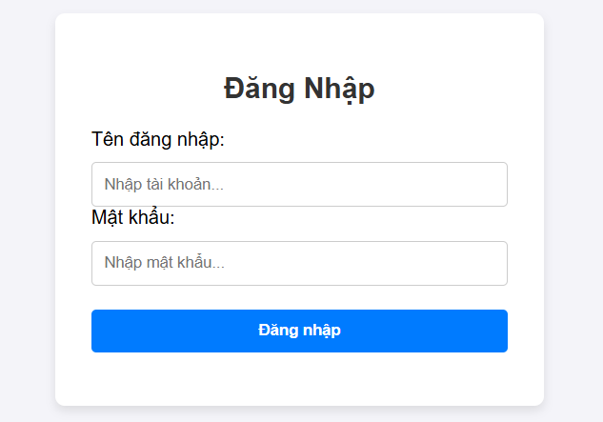
Figure 1: Sample Login Page Interface

2. Introduction to Robot Framework
Robot Framework is a powerful, open-source test automation framework developed in Python. This tool is designed with a Keyword-driven and Data-driven approach, allowing test engineers to write automation scripts using an easy-to-read tabular syntax that is close to natural language, without requiring highly complex programming skills.
The key features that make Robot Framework the ideal choice for this project include:
- Readability and Reusability: The keyword-driven syntax makes Test Cases transparent and easy to understand, even for those without a coding background.
- Support for Data-Driven Testing: It is perfectly suited for executing a single scenario (e.g., Login) repeatedly with dozens of different data sets (derived from Equivalence Partitioning and Boundary Value Analysis techniques) using the Test Template feature.
- Flexible Integration: It easily integrates with Selenium Library to interact directly with web browser elements (such as entering text, clicking buttons, and verifying error messages).
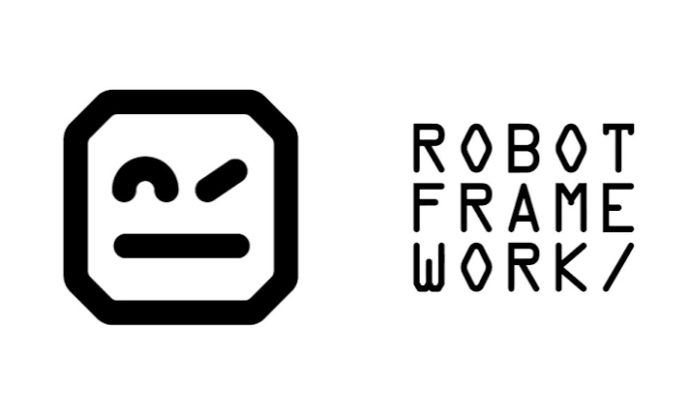
- Visual Reporting: It automatically generates highly detailed, color-coded (PASS/FAIL) result files (log.html, report.html), which helps testers quickly trace errors (debug) and finalize reports.

Figure 2: Robot Framework Logo

3. Test Case Details
3.1. BlackBox Testcase
Table 1: Black-Box Test Cases Table
TC ID | Test Case Name | Username / Password | Expected Result
TC01 | Successful login | Admin / admin123 | Login successful!
TC04 | Incorrect username | user_sai / admin123 | Login successful!
TC06 | Empty password | Admin / ${EMPTY} | Error: Please fill in all required fields!
TC07 | Empty username | ${EMPTY} / admin123 | Error: Please fill in all required fields!
TC08 | Both fields empty | ${EMPTY} / ${EMPTY} | Error: Please fill in all required fields!
TC09 | Username with special chars | Admin@123 / admin123 | Login successful!
TC10 | Password with space | Admin / admin 123 | Login successful!
TC11 | Username containing numbers | Admin123 / admin123 | Login successful!
TC12 | Excessively long username | Admin_Admin_Admin / admin123 | Login successful!
TC13 | Password numbers only | Admin / 123456789 | Login successful!
TC14 | Username with whitespace | Ad min / admin123 | Login successful!
TC15 | All uppercase password | Admin / ADMIN123 | Login successful!
TC16 | Email format username | admin@gmail.com / admin123 | Login successful!
TC17 | SQL Injection Username | ' OR '1'='1 / admin123 | Login successful!
TC18 | SQL Injection Password | Admin / ' OR '1'='1 | Login successful!
TC19 | HTML Tag Username | <h1>Admin</h1> / admin123 | Login successful!
TC20 | XSS Script Username | <script>alert(1)</script> / admin123 | Error: Account does not exist!
TC21 | Both incorrect | test_user / test_pass | Error: Account does not exist!
TC22 | Whitespace password | Admin / ${SPACE} | Error: Account does not exist!
TC23 | Whitespace username | ${SPACE} / admin123 | Error: Please fill in all required fields!
TC24 | Swapped username and password | admin123 / Admin | Error: Account does not exist!
TC25 | Wrong User, Correct Pass | NguoiLa / admin123 | Error: Account does not exist!
TC27 | Wrong expectation 1 | sai_user / sai_pass | Welcome to panel
TC28 | Wrong expectation 2 | Admin / ${EMPTY} | Please enter your password
TC29 | Wrong expectation 3 | ${EMPTY} / admin123 | Please enter your username
TC30 | Wrong expectation 4 | Admin / admin123 | System error 500

3.2. Equivalence Table
Table 2: Equivalence Partitioning Table
External Condition | Valid Equivalence Class | No. | Invalid Equivalence Class | No.
Username | Correct data ("Admin") | 1 | Empty (Not entered) | 3
 |  |  | Swapped position with password | 4
 |  |  | Incorrect capitalization format ("ADMIN") | 5
 |  |  | Contains whitespace (leading, trailing, mid) | 6
 |  |  | Contains special characters, accented, email | 7
 |  |  | Malicious code injection (SQLi, XSS, HTML) | 8
Password | Correct data ("admin123") | 2 | Empty (Not entered) | 9
 |  |  | Swapped position with username | 10
 |  |  | Incorrect uppercase/lowercase format ("ADMIN123") | 11
 |  |  | Contains whitespace (leading, trailing, mid) | 12
 |  |  | Malicious code injection (SQLi) | 13
Account Status | Active (Enabled) | 14 | Non-existent / suspicious account | 15

3.3. Equivalence Partitioning Test Case Mapping
Table 3: Equivalence Partitioning Test Case Mapping
Test Case | Covered Classes | Username / Password | Expected Result
TC04 | 4, 2, 14 | user_sai / admin123 | Login successful!
TC05 | 5, 2, 14 | ADMIN / admin123 | Login successful!
TC09 | 7, 2, 14 | Admin@123 / admin123 | Login successful!
TC10 | 1, 12, 14 | Admin / admin 123 | Login successful!
TC14 | 6, 2, 14 | Ad min / admin123 | Login successful!
TC15 | 1, 11, 14 | Admin / ADMIN123 | Login successful!
TC17 | 8, 2, 14 | ' OR '1'='1 / admin123 | Login successful!
TC18 | 1, 13, 14 | Admin / ' OR '1'='1 | Login successful!
TC25 | 15, 2, 14 | NguoiLa / admin123 | Account does not exist!

3.4. Boundary Table
Table 4: Boundary Value Analysis Table
Boundary Condition | Input Username (5-40 chars) | Input Password  (7-20 chars) | Expected Result
Username: Min - 1 | 4 chars ("Admi") | Valid ("admin123") | Login successful!
Username: Min | 5 chars ("Admin") | Valid ("admin123") | Login successful!
Username: Min + 1 | 6 chars ("Admin1") | Valid ("admin123") | Login successful!
Normal Value | 10 chars ("Admin Test") | 8 chars ("admin123") | Login successful!
Username: Max - 1 | 39 chars | Valid ("admin123") | Login successful!
Username: Max | 40 chars | Valid ("admin123") | Login successful!
Username: Max + 1 | 41 chars | Valid ("admin123") | Login successful!
Password: Min - 1 | Valid ("Admin") | 6 chars ("abcdef") | Login successful!
Password: Max + 1 | Valid ("Admin") | 21 chars | Login successful!
Empty Input | Empty ("") | Valid ("admin123") | Error: Please fill in all required fields!

3.5. Decision Table
Table 5: Decision Table
Condition / Action Stub | R1 | R2 | R3 | R4 | R5 | R6 | R7
Valid Username entered | T | F | T | F | F | T | F
Valid Password entered | T | T | F | F | T | F | F
At least one field is empty | F | F | F | F | T | T | T
Actions
Login successful! | ✓ | ✓ | ✓ | - | - | - | -
Error: Account does not exist! | - | - | - | ✓ | - | - | -
Error: Please fill in all required fields! | - | - | - | - | ✓ | ✓ | ✓

3.6. WhiteBox TestCases
Table 6: White-Box Test Cases Table
TC ID | Testcase Name | Username | Password | Expected Result | Status
TC02 | Incorrect password 1st time | Admin | sai_pass | Login successful! | PASS
TC03 | Incorrect password 2nd time | Admin | abcdef | Login successful! | PASS
TC05 | Uppercase username | ADMIN | admin123 | Login successful! | PASS
TC26 | Backdoor hacker | Hacker | sai_pass | Login successful! | PASS

3.7. Source Code
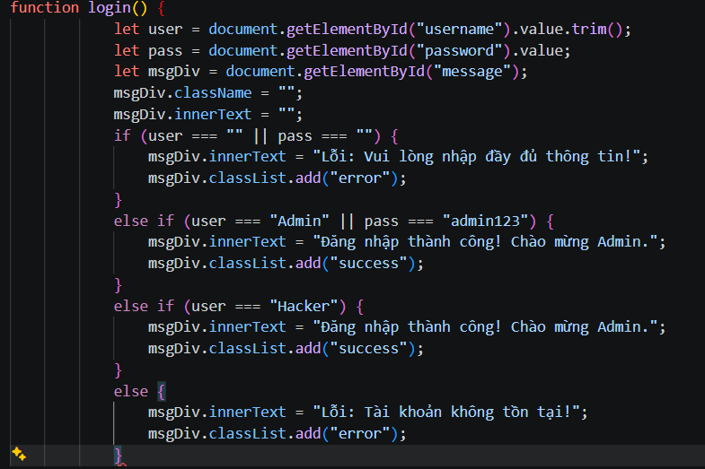
Figure 3: JavaScript Login Function Source Code

3.8. Control Flow Graph ( CFG )
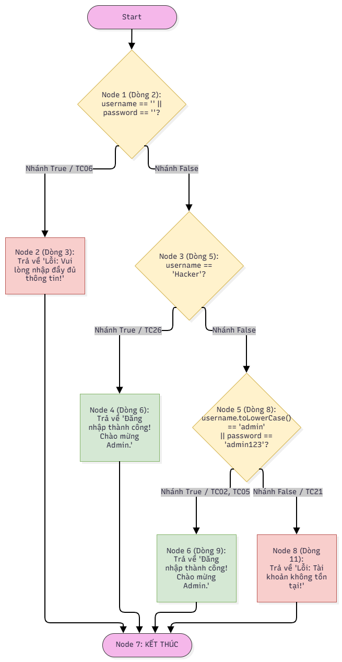
Figure 4: Control Flow Graph - CFG

3.9. Statement Coverage
Table 7: Statement Coverage Table
TC ID | Input | Path | Covered Code Lines | Expected Result
TC06 | username = "Admin"  password = "" | Node 1 -> Node 2 -> Node 7 | Line 2, Line 3 | Error: Please fill in all required fields!
TC26 | username = "Hacker"  password = "sai_pass" | Node 1 -> Node 3 -> Node 4 -> Node 7 | Line 2, Line 5, Line 6 | Login successful!
TC02 | username = "Admin"  password = "sai_pass" | Node 1 -> Node 3 -> Node 5 -> Node 6 -> Node 7 | Line 2, Line 5, Line 8, Line 9 | Login successful!
TC21 | username = "test_user"  password = "test_pass" | Node 1 -> Node 3 -> Node 5 -> Node 8 -> Node 7 | Line 2, Line 5, Line 8, Line 11 | Error: Account does not exist!

3.10. Branch Coverage
Table 8: Branch Coverage Table
TC ID | Input | Condition Tested | Branch Result | Path
TC06 | username = "Admin"  password = "" | Line 2: username == "" || password == "" | True | Node 1 -> Node 2 -> Node 7
TC26 | username = "Hacker"  password = "sai_pass" | Line 2: username == "" || password == "" | False | Node 1 -> Node 3
TC26 | username = "Hacker"  password = "sai_pass" | Line 5: username == "Hacker" | True | Node 3 -> Node 4 -> Node 7
TC02 | username = "Admin"  password = "sai_pass" | Line 5: username == "Hacker" | False | Node 3 -> Node 5
TC05 | username = "ADMIN"  password = "admin123" | Line 8: username.toLowerCase() == "admin" || ... | True | Node 5 -> Node 6 -> Node 7
TC21 | username = "test_user"  password = "test_pass" | Line 8: username.toLowerCase() == "admin" || ... | False | Node 5 -> Node 8 -> Node 7

4. Summary Table
Table 9: Comprehensive Summary Test Results Table for 30 Test Cases
TC ID | Technique | Test Case Name | Username / Password | Expected Result | Status
TC01 | Blackbox | Successful login | Admin / admin123 | Login successful! | PASS
TC02 | Whitebox | Incorrect password 1st time | Admin / sai_pass | Login successful! | PASS
TC03 | Whitebox | Incorrect password 2nd time | Admin / abcdef | Login successful! | PASS
TC04 | Blackbox | Incorrect username | user_sai / admin123 | Login successful! | PASS
TC05 | Whitebox | Uppercase username | ADMIN / admin123 | Login successful! | PASS
TC06 | Blackbox | Empty password | Admin / ${EMPTY} | Error: Please fill in all required fields! | PASS
TC07 | Blackbox | Empty username | ${EMPTY} / admin123 | Error: Please fill in all required fields! | PASS
TC08 | Blackbox | Both fields empty | ${EMPTY} / ${EMPTY} | Error: Please fill in all required fields! | PASS
TC09 | Blackbox | Username with special chars | Admin@123 / admin123 | Login successful! | PASS
TC10 | Blackbox | Password with space | Admin / admin 123 | Login successful! | PASS
TC11 | Blackbox | Username containing numbers | Admin123 / admin123 | Login successful! | PASS
TC12 | Blackbox | Excessively long username | Admin_Admin_Admin / admin123 | Login successful! | PASS
TC13 | Blackbox | Password numbers only | Admin / 123456789 | Login successful! | PASS
TC14 | Blackbox | Username with whitespace | Ad min / admin123 | Login successful! | PASS
TC15 | Blackbox | All uppercase password | Admin / ADMIN123 | Login successful! | PASS
TC16 | Blackbox | Email format username | admin@gmail.com / admin123 | Login successful! | PASS
TC17 | Blackbox | SQL Injection Username | ' OR '1'='1 / admin123 | Login successful! | PASS
TC18 | Blackbox | SQL Injection Password | Admin / ' OR '1'='1 | Login successful! | PASS
TC19 | Blackbox | HTML Tag Username | <h1>Admin</h1> / admin123 | Login successful! | PASS
TC20 | Blackbox | XSS Script Username | <script>alert(1)</script> / admin123 | Error: Account does not exist! | FAIL
TC21 | Blackbox | Both incorrect | test_user / test_pass | Error: Account does not exist! | PASS
TC22 | Blackbox | Whitespace password | Admin / ${SPACE} | Error: Account does not exist! | FAIL
TC23 | Blackbox | Whitespace username | ${SPACE} / admin123 | Error: Please fill in all required fields! | PASS
TC24 | Blackbox | Swapped username and password | admin123 / Admin | Error: Account does not exist! | PASS
TC25 | Blackbox | Wrong User, Correct Pass | NguoiLa / admin123 | Error: Account does not exist! | FAIL
TC26 | Whitebox | Backdoor hacker | Hacker / sai_pass | Login successful! | PASS
TC27 | Blackbox | Wrong expectation 1 | sai_user / sai_pass | Welcome to panel | FAIL
TC28 | Blackbox | Wrong expectation 2 | Admin / ${EMPTY} | Please enter your password | FAIL
TC29 | Blackbox | Wrong expectation 3 | ${EMPTY} / admin123 | Please enter your username | FAIL
TC30 | Blackbox | Wrong expectation 4 | Admin / admin123 | System error 500 | FAIL

5. Evidence
5.1. Test Scripts & Execution Logs
The automated testing was implemented using Robot Framework integrated with the Browser Library (Playwright) to simulate user interactions on the web application. The test suite is designed with a data-driven approach using Test Templates, allowing efficient execution of 30 distinct scenarios ranging from basic boundary validations to security payload injections.
Key technical details of the execution include:
- Setup/Teardown: Automated launching of Chromium browser in non-headless mode, clearing state between tests to ensure test isolation.
- Test Execution: Executed via Command Line Interface (CLI), processing 30 Test Cases continuously.
- Test Output: Generated detailed log.html and report.html tracking the trace of every Keyword step, Assertion state, and overall Pass/Fail statistics.
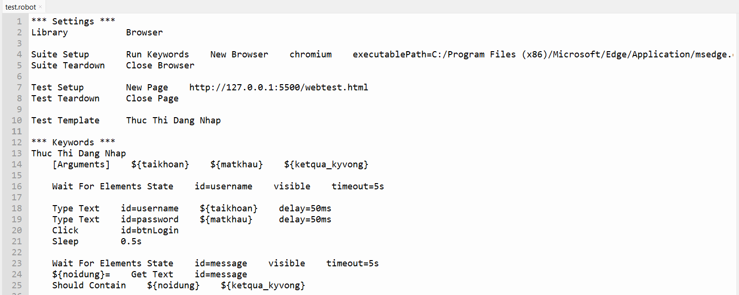
Figure 5: Robot Framework Test Script

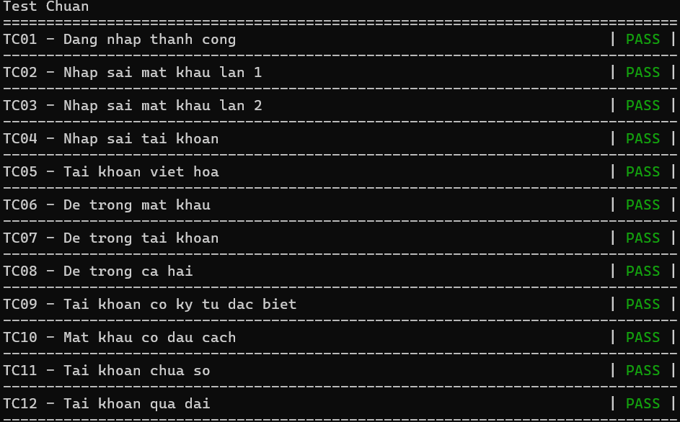
Figure 6: Terminal CLI Execution Output ( TC01-TC12)
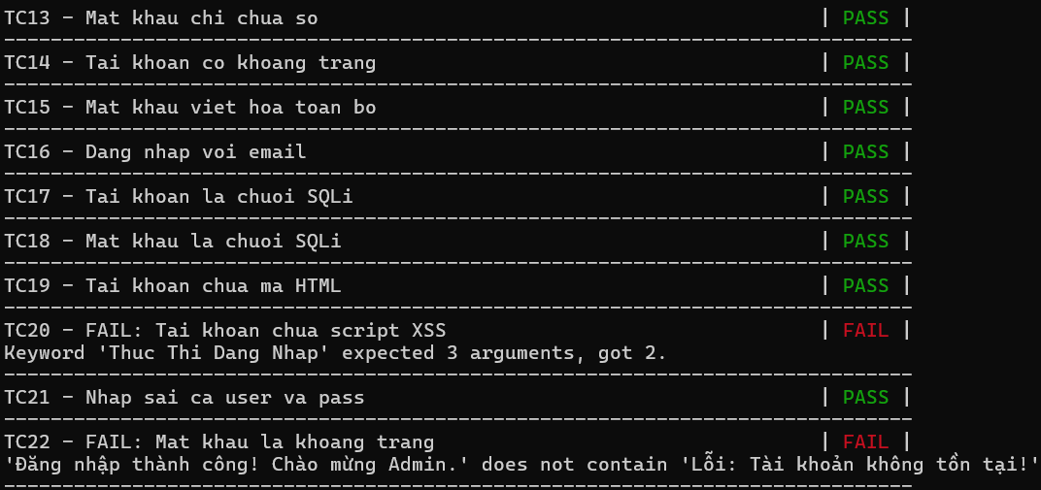
Figure 7: Terminal CLI Execution Output ( TC13-TC22 )
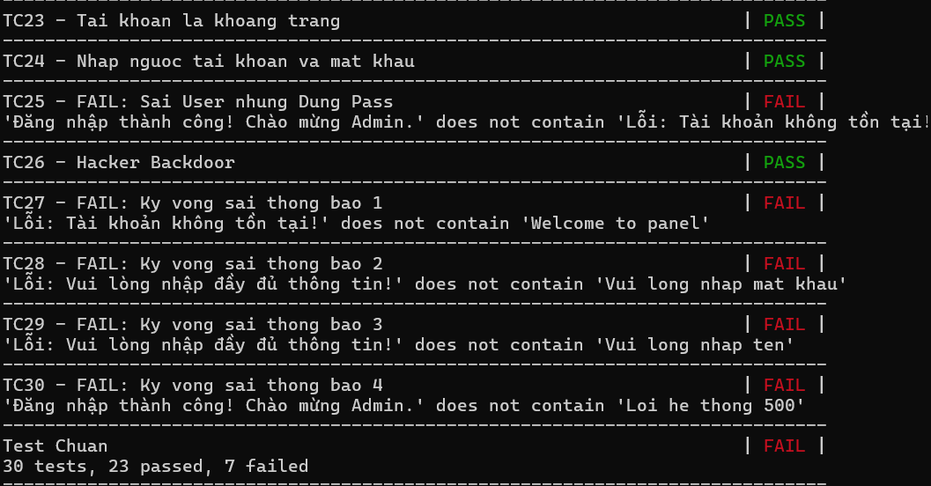
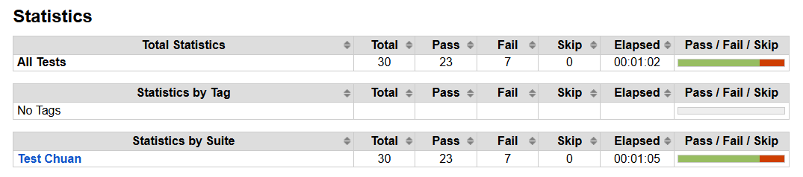
Figure 8: Terminal CLI Execution Output ( TC23-TC30 )
- Detailed Analysis of Failed Test Cases:
Figure 9: Test Statistics Summary Report

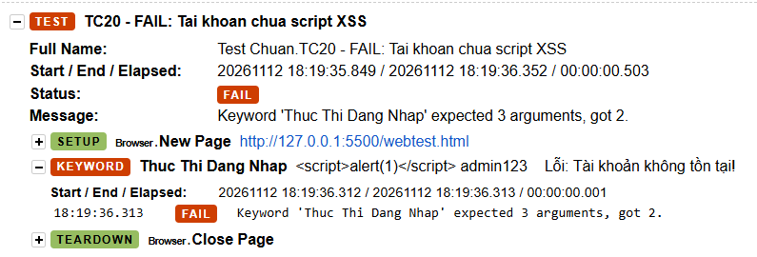
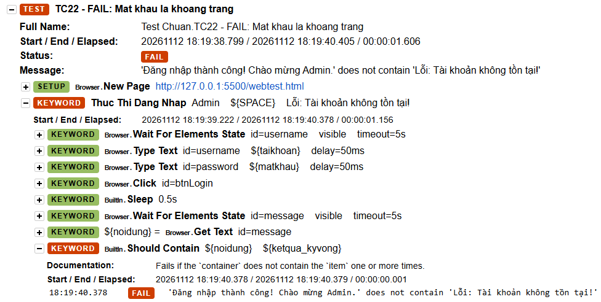
Figure 10: Execution Log of Failed Test Case TC20
Figure 11: Execution Log of Failed Test Case TC22
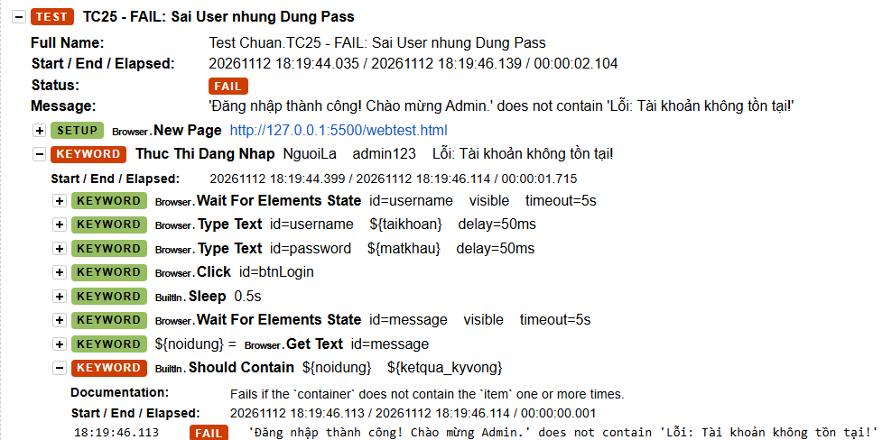
Figure 12: Execution Log of Failed Test Case TC25
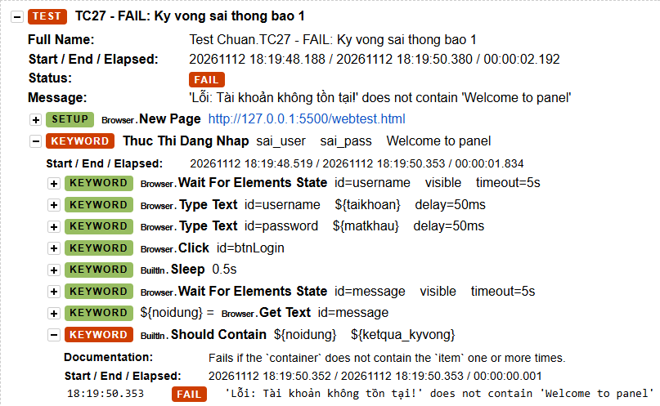
Figure 13: Execution Log of Failed Test Case TC27
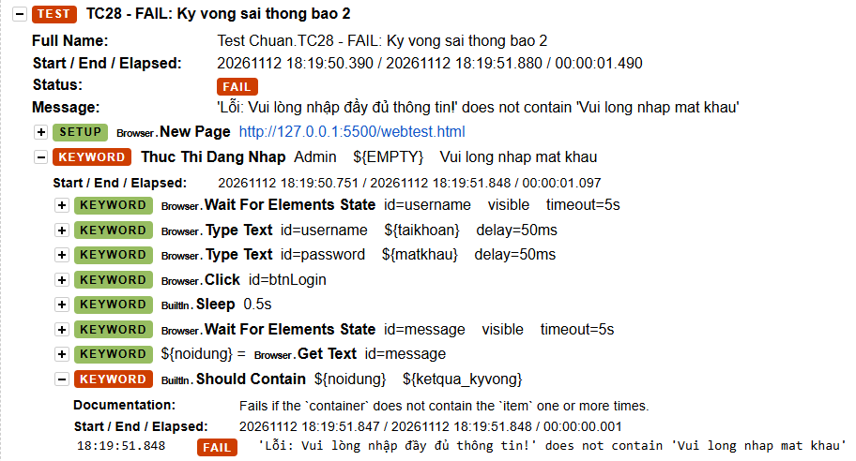
Figure 14: Execution Log of Failed Test Case TC28
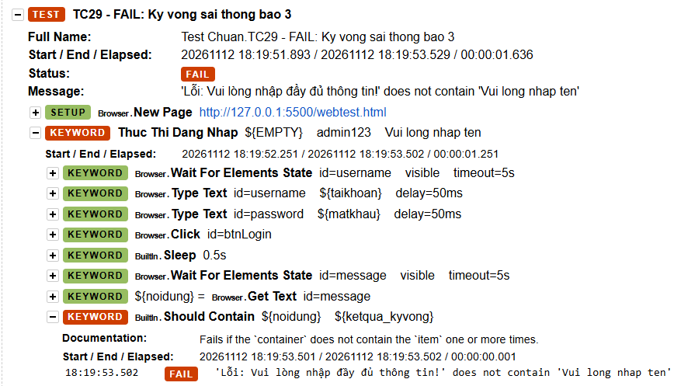
Figure 15: Execution Log of Failed Test Case TC29
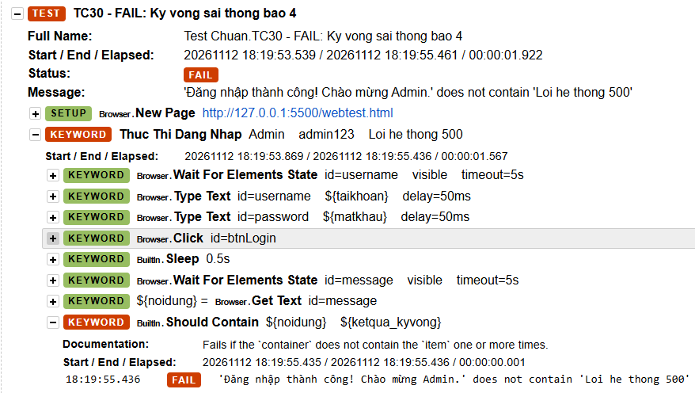
Figure 16: Execution Log of Failed Test Case TC30
5.2. Summary of Defects and Issues Found During Execution
During the automated execution of the 30 test cases, 23 test cases passed and 7 failed (TC20, TC22, TC25, TC27, TC28, TC29, and TC30). A detailed investigation of the execution logs categorizes the findings into two main groups: critical application defects and test script/assertion issues.
1. Application Bugs (Functional & Security Vulnerabilities):
- Authentication Logic Bypass (Logical OR instead of AND): In the backend login validation (username.toLowerCase() == "admin" || password == "admin123"), the developer erroneously used the logical OR (||) operator instead of AND (&&). As a result, entering either a valid username OR a valid password is sufficient to gain access. This caused TC22 (valid username "Admin" with whitespace password) and TC25 (non-existent username "NguoiLa" with valid password "admin123") to bypass authentication instead of returning an error message.
- Hardcoded Administrative Backdoor: White-box code analysis and automated execution (TC26) exposed a hidden backdoor condition (if (username == "Hacker")) that grants immediate administrative access regardless of the password entered.
- Case-Insensitive Username & Lack of Input Sanitization: The application converts usernames using .toLowerCase() (allowing uppercase variations like "ADMIN" in TC05), fails to trim leading/trailing/embedded whitespaces (TC10, TC14, TC22), lacks minimum/maximum length constraints (TC12 and Boundary tests), and does not sanitize raw SQL Injection or HTML payloads (TC17, TC18, TC19).
2. Script & Test Data Assertion Issues:
- Argument Parsing Error in TC20 (XSS Payload): TC20 failed at the framework execution level with the message: "Keyword 'Thuc Thi Dang Nhap' expected 3 arguments, got 2." This occurred because the special characters/spacing inside the raw XSS payload (<script>alert(1)</script>) interfered with Robot Framework's space-separated data table parser.
- Intentional Negative Assertion Failures (TC27 – TC30): These four test cases were deliberately configured with incorrect expected messages (e.g., expecting "Welcome to panel" or "System error 500") to verify that the Robot Framework assertion keyword (Should Contain) accurately detects mismatches and flags failed test scenarios in the final report.

6. Conclusion
In this project, an automated functional testing suite was successfully designed, implemented, and executed using Robot Framework and the Browser Library to evaluate The Login Testing Application (TLTA). By systematically combining Black-box testing techniques (Equivalence Partitioning, Boundary Value Analysis, and Decision Table Testing) with White-box testing techniques (Control Flow Graph analysis achieving 100% Statement Coverage and 100% Branch Coverage), a comprehensive suite of 30 data-driven test cases was constructed and automated.
The test suite executed automatically in 60 seconds without manual intervention, achieving 23 passed tests and identifying 7 failed cases. Through this automated process, critical security and logic vulnerabilities in the application were effectively uncovered—most notably the authentication OR operator flaw, the hardcoded "Hacker" backdoor, and the lack of input validation.
Overall, this project demonstrates how pairing structured software testing methodologies with keyword-driven automation ensures high test coverage, reliable defect detection, and comprehensive reporting.

